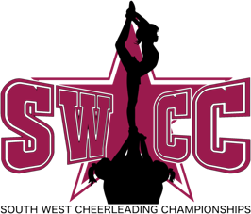

Team Name:
Coach Name:

Coach Contact email:
Coach Contact Number:
Participants Name:
Competition Date:

Competition entered – SOUTH WEST CHEERLEADING CHAMPIONSHIPS

Category entered - please circle or highlight as appropriate:

Cheerleading Pom Dance Display Group Stunt Partner Stunt
If you have circled display please note the Category and division here..............................................................

Age group / level entered - please circle or highlight as appropriate:

Tiny Teenies Teenies Junior A Junior B Senior Masters
Level 1 Level 2 Level 3 Level 4 Level 5 Level 6

Low Level (if Pom Competition) High level (if Pom Competition)
Hard Medical Items - please describe

Any Previous Injuries - includes breaks, fractures, strains, sprains, etc. - please confirm name of Cheerleader and describe injury

Risk Assessment:
I confirm that a full Risk Assessment has been carried out and all necessary precautions have/will be taken
to reduce the element of risk whilst …………………………………………………….…….. is participating in this event.
I confirm that all team members are aware of the risk and consent to perform with above named.
I accept responsibility for managing all risk and any injuries caused.
Signed Coach Name Date

